GLMM analysis for: State of knowledge on bats’ contribution to agricultural pest suppression and interventions to support them: a global survey of researchers

Socio-economic indices being explored:
- GDP
- National R&D Investment (all sectors)
- Agricultural Economy Dependence (% of GDP from Agriculture, Forestry and Fisheries)
- Agricultural R&D Investment
- Environmental Performance Index

Accessing these datasets:
- Extracted from World Bank.org directly in R using library(WDI):
  - GDP: indicator = "NY.GDP.PCAP.CD"
  - National R&D Investment (all sectors): indicator = "GB.XPD.RSDV.GD.ZS"
  - Agricultural Economy Dependence (% of GDP from Agriculture, Forestry and Fisheries): indicator = "NV.AGR.TOTL.ZS"
- Extracted from ‘Grape’ dataset: https://www.nature.com/articles/s41597-025-05331-y?utm_source=researchgate.net&utm_medium=article#Sec10 and https://zenodo.org/records/15507361
  - Agricultural R&D Investment
- Downloaded from https://epi.yale.edu/downloads :
  - Environmental Performance Index

Bat Species Richness
- Also included in models as we hypothesised that it may be harder to gain knowledge about bats role in agricultural system if there is very high bat diversity.
- Data access: Bat species lists initially downloaded for each country from batnames.org, but cross-checked against mammaldiversity.org and iucn to filter out extinct species on the batnames.org list.

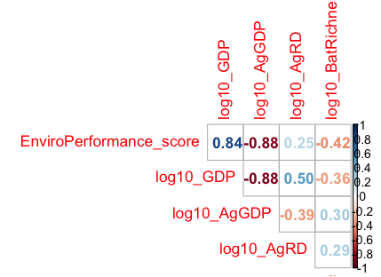
Correlation among predictors:
These are the only 'safe' combinations (less than 0.6):
- Env Performance and All R&D
- Env Performance and Ag R&D
- GDP and Ag R&D
- All R&D and Ag R&D
- Ag contribution to GDP and All R&D
- BatRichness with all others

But, we can only afford 2 predictors anyway, so unless bat spp richness is not important, then including more than one socio-economic index may result in overfitting.

Model variables and structure:
Random effects:
- (1 | Country) - This accounts for multiple respondents per country sharing the same GDP/Env Performance etc value.
- (1 | Respondent) - This accounts for multiple responses per person.
Fixed effects:
- Score.type -
We have responses from 24 countries, and the socio-economic and bat species richness data will be at country level. Therefore, we can only ‘afford’ 2 predictors (in addition to score.type?) following the 10 observations per predictor rule (excluding random effects). We should prioritise finding the ‘best’ socio-economic predictor and considering how bat species richness may affect ability to gain knowledge.
- BatRichness (at country level)
- 1 of the socio-economic indices: GDP, Env Performance, Ag R&D, Ag economy dependence
Error family:
- Logit? (Default) – Look at distribution of scores. Could maybe use a loglog link for the Survey 2 data since the scores for most types are skewed towards 0 (but not for bat education...).
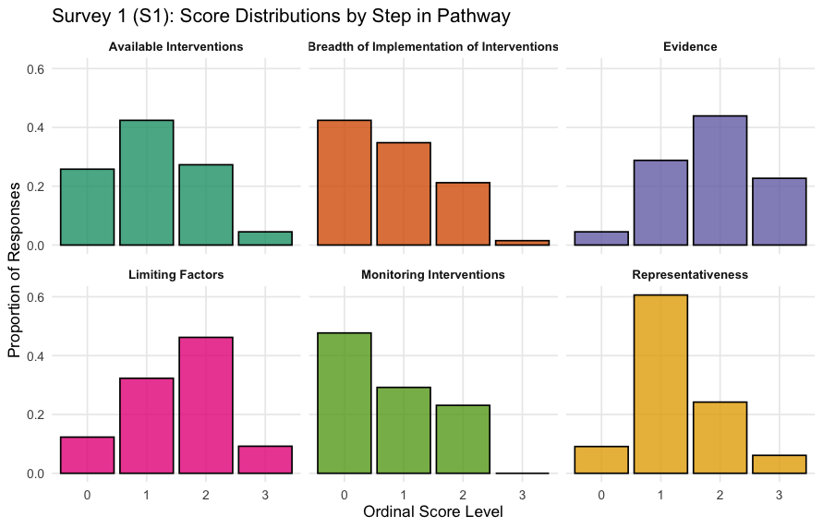

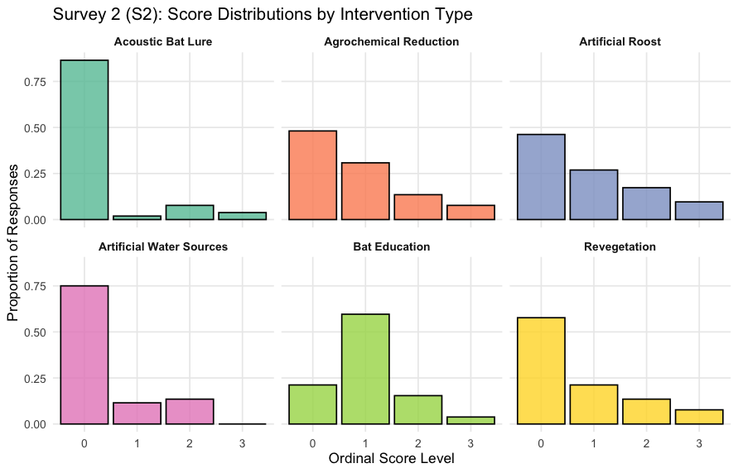
Therefore, our basic model structure is:
S1_null_glmmTMB <- clmm(Ordinal score ~ Best socio-economic index * Score.type +
(1|Country.clean) + (1|Respondent.clean),
link = "logit", data = dat)
Model comparisons
First I needed to create a ‘complete-case’ dataset, where there are no NA’s for any of the predictors.

Then I ran dredge(), specifying which correlated variables could not be included together (with subset =), and the max number of fixed effects (with m.lim = )

Survey 1 – Response variable = score for each step in the pathway (score.type)

Model comparison (grey dashed line = 2 AICc’s above best)
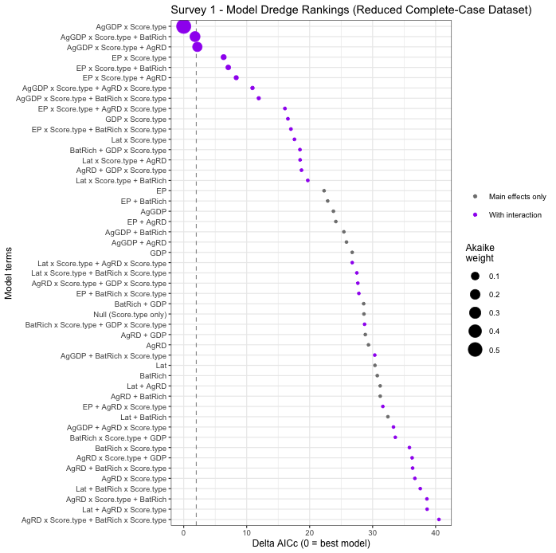
AICc etc of models within 2 AICcs of best
Model terms | Structure | df | logLik | AICc | Delta AICc | Akaike weight
Score.type + AgGDP x Score.type | With interaction | 16 | -389.8 | 813.1 | 0.00 | 0.543
Score.type + AgGDP x Score.type + BatRich | With interaction | 17 | -389.6 | 814.8 | 1.79 | 0.221
Does adding Bat Richness improve the model if we use the full dataset (no NAs for AgGDP or BatRichness, but we don’t care about EnvPerformance etc).
Model | df | AICc | Delta AICc
Score. type + AgGDP + AgGDP x Score.type + Bat Richness | 17 | 909.18 | 1.7397
Score.type + AgGDP + AgGDP x Score.type | 16 | 907.44 | 0.0
- No, so proceed with the model without BatRichness

Refit best model (AgGDP) on the complete dataset, and check whether an interaction with Score.type is needed
Model | df | AICc | Delta AICc
Score.type only (null) | 10 | 956.4 | 37.8
Score.type + AgGDP | 11 | 948.2 | 29.6
Score.type + AgGDP + AgGDP x Score.type | 16 | 918.6 | 0.0
- Yes, the model with the interaction is best, so proceed with it

Continue with the best model for post-hocs:
Post-hoc test of AgGDP effect on scores at each step in the pathway:
Step in knowledge pathway | Slope of AgGDP effect | SE | df | Lower CI | Upper CI | z | p (Holm)
Evidence | 0.56 | 0.36 | Inf | -0.39 | 1.51 | 1.55 | 0.12039
Representativeness | -1.38 | 0.35 | Inf | -2.31 | -0.45 | -3.93 | < 0.001
Limiting Factors | -0.88 | 0.35 | Inf | -1.81 | 0.05 | -2.51 | 0.02415
Available Interventions | -0.95 | 0.35 | Inf | -1.87 | -0.03 | -2.72 | 0.01941
Monitoring Interventions | -1.10 | 0.36 | Inf | -2.06 | -0.14 | -3.03 | 0.00985
Breadth of Implementation of Interventions | -1.72 | 0.39 | Inf | -2.74 | -0.69 | -4.42 | < 0.001
Each row tests whether the AgGDP slope for that step differs from zero. Slopes are log-odds of a higher score per +1 SD of log10 AgGDP (negative = lower scores in more agriculture-dependent countries), from the refitted model (24 countries). CIs and p-values are Holm-adjusted across the six steps.

Visualise with slope estimates & p-vals:
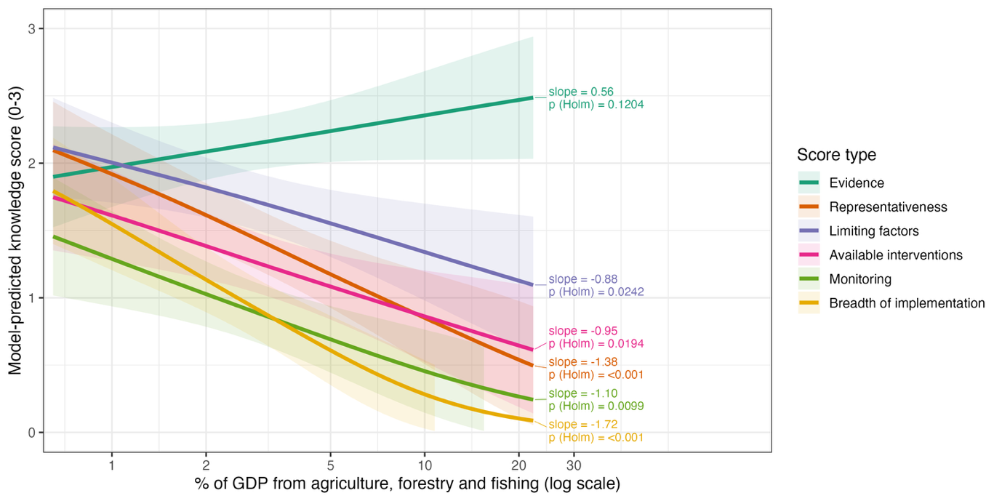

Model diagnostics for best Survey 1 model: 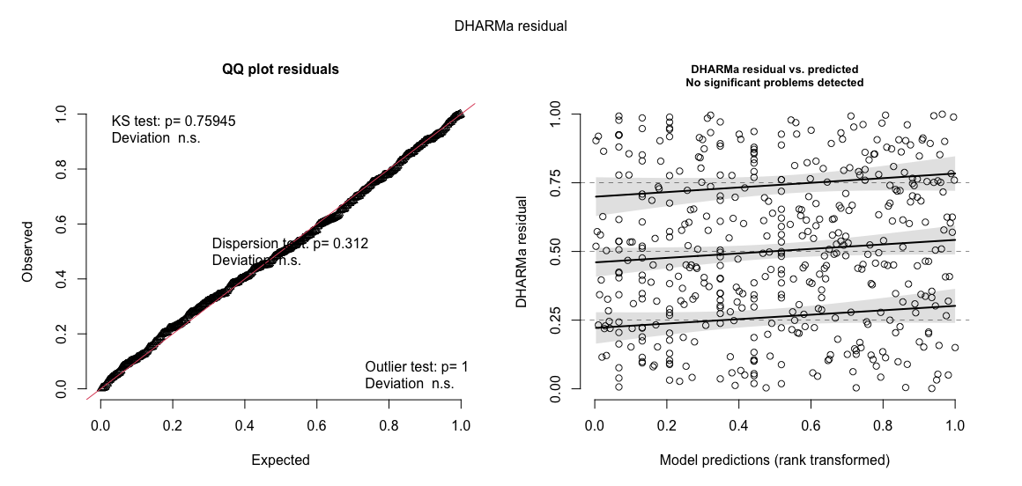

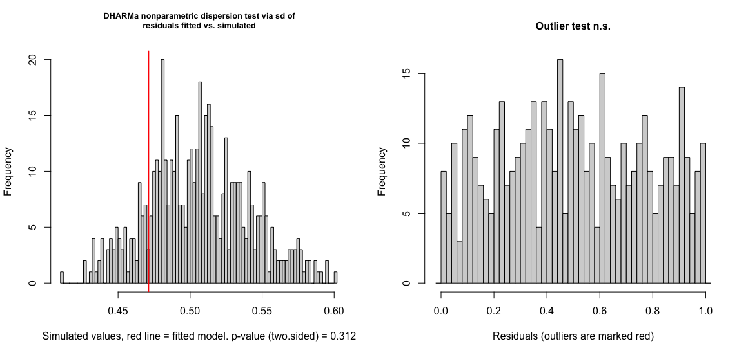

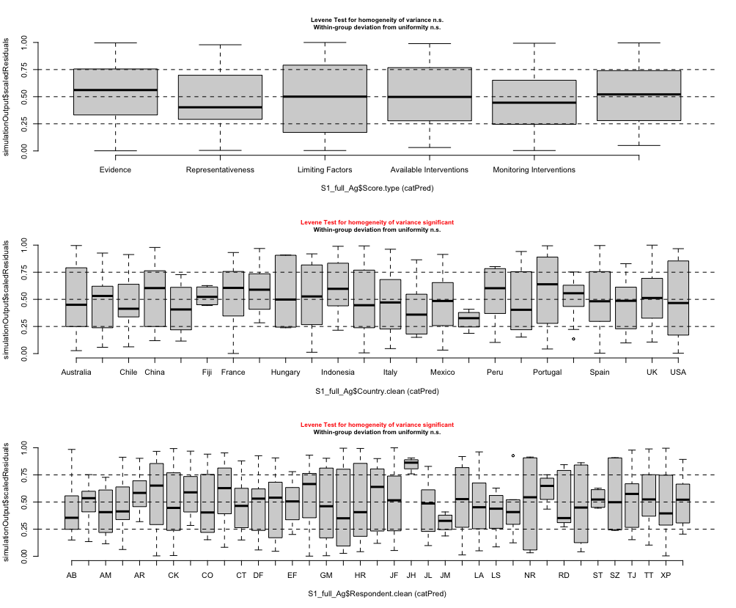

Survey 2 – Response variable = score for each intervention
Model comparison (grey dashed line = 2 AICc’s above best)

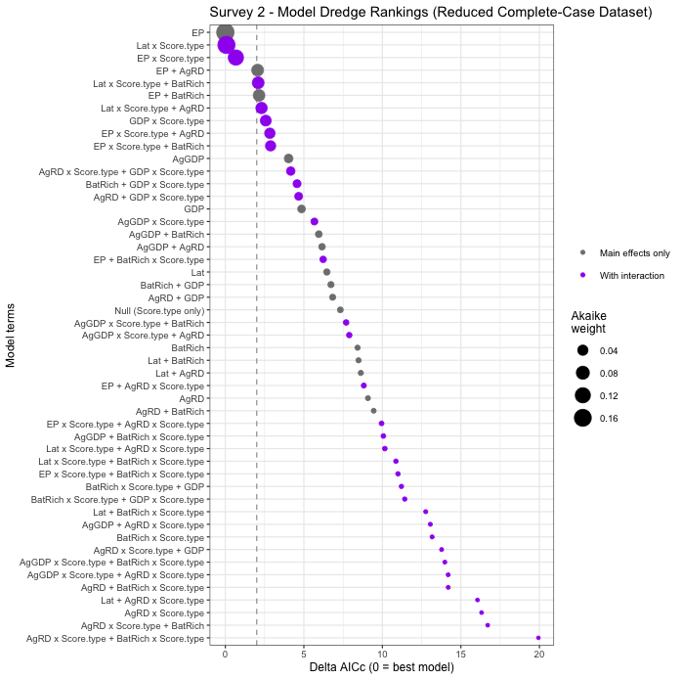

AICc etc of models within 2 AICcs of best
Model terms | Structure | df | logLik | AICc | Delta AICc | Akaike weight
Score.type + EP | Main effects only | 11 | -316.1 | 655.0 | 0.00 | 0.171
Score.type + Lat x Score.type | With interaction | 16 | -310.6 | 655.1 | 0.07 | 0.165
Score.type + EP x Score.type | With interaction | 16 | -310.9 | 655.7 | 0.67 | 0.122

Refit best model (EnvPerformance) on the complete dataset, and check whether an interaction with Score.type is needed
Model | df | AICc | Delta AICc
Score.type only (null) | 10 | 742.4 | 10.8
Score.type + EP | 11 | 733.8 | 2.2
Score.type + EP + EP x Score.type | 16 | 731.6 | 0.0
- Yes, the model with the interaction is best, so proceed with it
- Why does this conflict with the dredge results? The dredge screening was restricted to a subset of rows where all siz country-lebel predictors had complete data (no NAs). On that restricted dataset, the main-effects version of the Environmental Performance Index (EPI) model came out on top, with no interaction to Score.type. However, when I re-specified the models using the full dataset, all the rows that had valid EPI metrics but were missing values for the other indices were recovered. And in this case, the ineraction model was better (lower AICc).

Continue with the best model for post-hocs

Post-hoc test of EP effect on scores for testing of each intervention:
Intervention | Slope of EP effect | SE | df | Lower CI | Upper CI | z | p (Holm)
Artificial Roost | 0.34 | 0.29 | Inf | -0.42 | 1.10 | 1.18 | 0.7130
Agrochemical Reduction | 0.90 | 0.32 | Inf | 0.06 | 1.74 | 2.82 | 0.0292
Revegetation | 0.84 | 0.35 | Inf | -0.07 | 1.76 | 2.42 | 0.0676
Bat Education | -0.16 | 0.25 | Inf | -0.83 | 0.50 | -0.65 | 1.0000
Artificial Water Sources | 1.29 | 0.52 | Inf | -0.09 | 2.67 | 2.47 | 0.0676
Acoustic Bat Lure | 0.28 | 0.43 | Inf | -0.84 | 1.40 | 0.65 | 1.0000
Each row tests whether the EP slope for that intervention differs from zero. Slopes are log-odds of a higher score per +1 SD of Environmental Performance score, from the refitted model (24 countries). CIs and p-values are Holm-adjusted across the six interventions.

Visualise with slope estimates & p-vals:
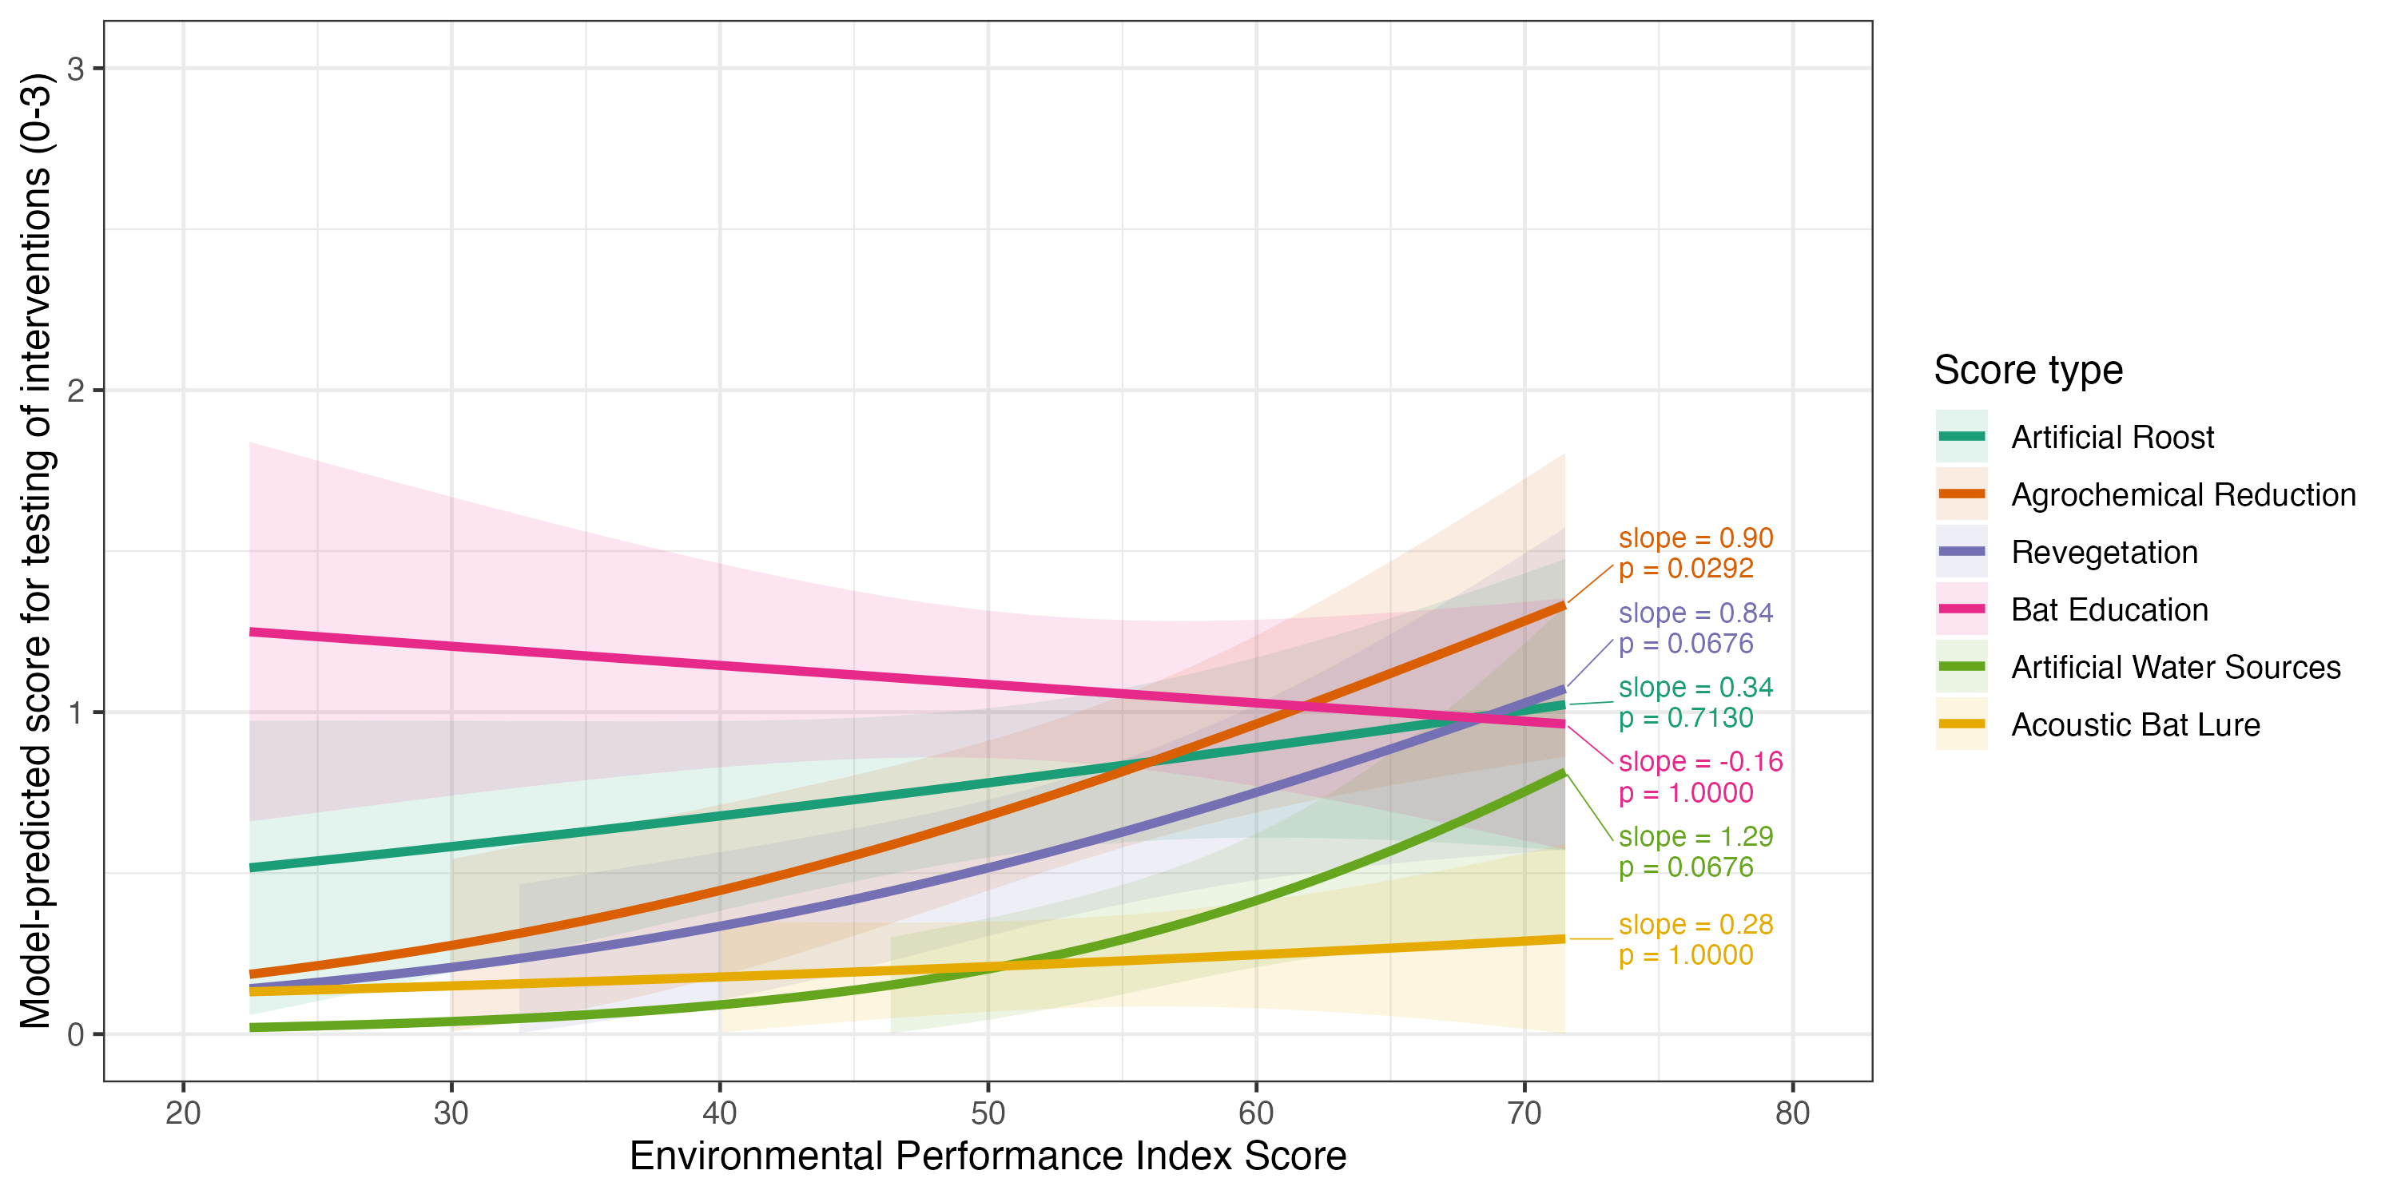

Model diagnostics for best Survey 2 model: 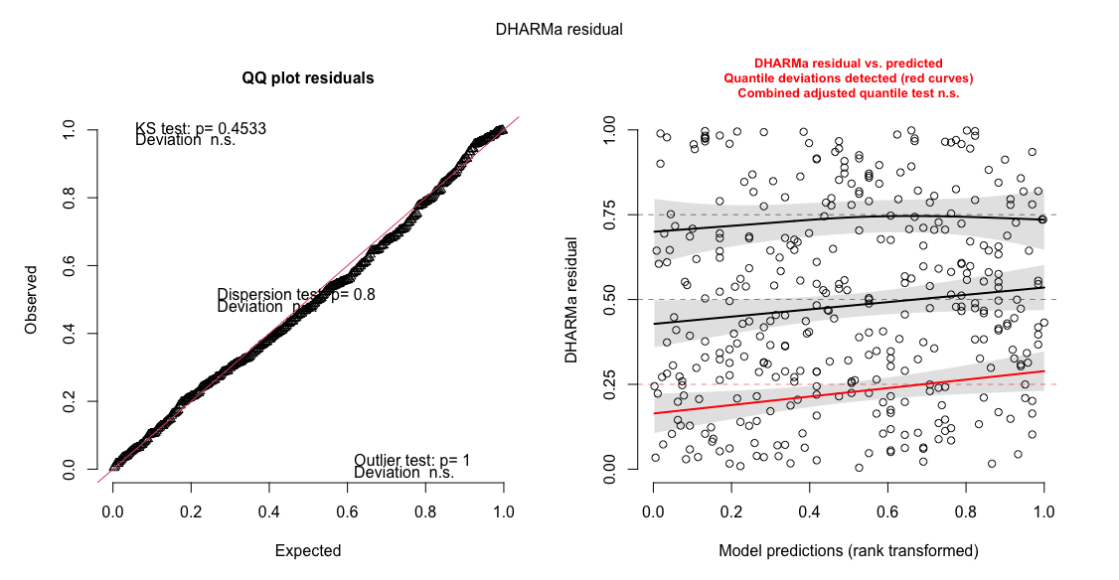
- Sig quantile deviations

